МИНИСТЕРСТВО НАУКИ И ВЫСШЕГО ОБРАЗОВАНИЯ  
РОССИЙСКОЙ ФЕДЕРАЦИИ

федеральное государственное автономное   
образовательное учреждение высшего образования  
«Самарский национальный исследовательский университет   
имени академика С.П. Королева»

(Самарский университет)

Институт информатики, математики и электроники

Факультет информатики  
Кафедра суперкомпьютеров и общей информатики

**Отчет по лабораторной работе № 2**

Дисциплина: «Enterprise Systems Development (Методы проектирования и поддержки требований к программному обеспечению)»

Тип предприятия: **«Cinema chain»**

Выполнил: Мелешенко И. С.

Группа: 6133-010402D

Самара 2022

**СОДЕРЖАНИЕ**

1 Assignment #2. Specification of system requirements. Use Case diagram. Scenarios 3

2 Лабораторная работа №2. Specification of system requirements. Use Case diagram. Scenarios 4

2.1 Задание №1. 4

2.2 Задание №2. 4

2.3 Задание №3. 4

2.4 Задание №4. 5

2.5 Задание №5. 5

2.6 Задание №6. 9

# 1 Assignment #2. Specification of system requirements. Use Case diagram. Scenarios

Tasks

1. Choose one of the company type from the excel list or use your own company type. In the course of the assignments, you will have to describe and suggest some business processes automating of the selected company.

2. Define list of high-level customer’s needs, which going to be solved by the information system implementation. Not less than 5 use cases in list.

3. Create Glossary of subject domain terms, which you will use next.

4. Create Use Case diagram for the described use cases. Diagram should include situation with at least two actors collaboration. Create Use Case diagram image (png/jpeg/gif). Add image to doc report (see template in [https://github.com/j-avdeev/EnterpriseSystemsDevelopment/tree/](https://github.com/j-avdeev/EnterpriseSystemsDevelopment/tree/2021/Assignment%20Reports%20Template)[2021/Assignment%20Reports%20Template](https://github.com/j-avdeev/EnterpriseSystemsDevelopment/tree/2021/Assignment%20Reports%20Template))

5. Write scenario for each use case using template: use case name, actors, goal, short description, basic script, exceptions (if exist).

6. Complete scenarios with examples of Screen forms, Documents to be created by your information system. For example, Registration Form, Acceptance Form, Bill screen, Internet invoice, Order in the online store, Medical services bill, etc.

Notice

For UML diagram plotting you can use draw.io (<https://www.draw.io/>), StarUML (<http://staruml.io/>) or another available software tools.

# 2 Лабораторная работа №2. Specification of system requirements. Use Case diagram. Scenarios

## 2.1 Задание №1.

A cinema chain was chosen as the type of company.

The purpose of the system: online purchase of movie tickets.

Actors: client, movie server, bank payment portal.

## 2.2 Задание №2.

The information system allows:

1. Registration and authorization in the system;

2. Movie selection;

3. Ticket purchase;

4. Ticket refund;

5. The choice of cinema.

The system must allow authorization. The customer must register independently and enter the data necessary to purchase a future ticket. The electronic ticket is a pdf file with a QR code, with information about the cinema and the movie. When canceling a purchase, a certain amount of money is refunded to the customer (depending on how late the decision to cancel the purchase was made).

## 2.3 Задание №3.

Glossary:

The client is a person to whom the film is shown in accordance with the contract (ticket).

Movie server is a server that provides up-to-date and available movie tickets for booking.

The bank payment portal is a portal where money transactions are carried out online.

## 2.4 Задание №4.

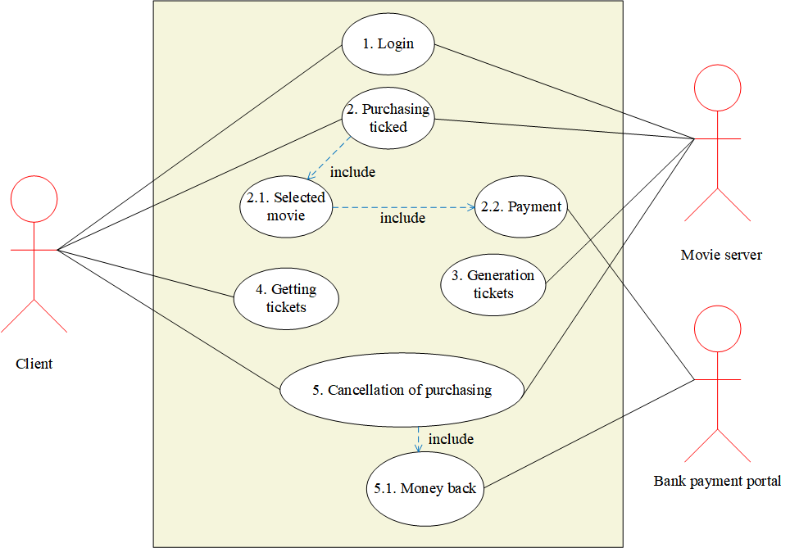  
Рисунок 5 – Use Case диаграмма

## 2.5 Задание №5.

***Use Case 1***

**Use Case:** Log in

**Actors:** Movie Server / Client

**Goal:** Create and Login to account

**Short description:** Client fills out the registration form to create an account in the system and login form to sign in an account.

**Scenario:**

1. Client goes on the website of purchasing movie ticket
2. Client click button “Registration”
3. Client fills out form

Input form:

First name: ______

Last name: ______

Email: __________

Password: _______

1. Client click button “Create account”
2. Client fills out form

Input form:

Email: _______

Password: ____

1. Client click button “Log in”

***Use Case 2***

**Use Case:** Purchasing ticket

**Actors:** Movie Server / Client

**Goal:**  View and purchasing available tickets

**Short description:** Client purchasing tickets

**Scenario:**

1. Client goes on the website of purchasing movie ticket
2. Client views list of tickets

View: Tickets are listed one after another

Characteristics: tickets features shown in the tickets list (cinema, movie, price, time and date of watching the movie, seat in the hall).

Filters: The client can filter tickets by the name of the movie, cinema, price, date and time of watching the movie.

Search: The client can search for tickets by movie name, cinema, price, movie viewing date.

***Use Case 2.1***

**Use Case:** Selected movie

**Actors:** Client

**Goal:** The client chooses the movie he likes

**Short description:** The client selects the movie he likes using filters

**Scenario:**

1. The client uses filters or search
2. The client clicks the "Search" button
3. The client chooses a movie ticket suitable for all his conditions
4. The client click “Next” button

***Use Case 2.2***

**Use Case:** Payment

**Actors:** Bank Payment portal / Client

**Goal:** Purchasing a ticket

**Short description:** To reserve the selected ticket

**Scenario:**

1. The client goes to the payment page
2. Product add to shopping cart
3. Customer can continues add product in shopping cart(point 3-4) or go to payment page
4. Passenger fills out a form

Input form:

bank card number: _____________

cvv code: ____

***Use Case 3***

**Use Case:** Ticket generation

**Actors:** Movie server

**Goal:** Ticket generation

**Short description:** The server generates a unique ticket

**Scenario:**

1. Create a unique ticket number, pdf file and qr code

***Use Case 4***

**Use Case:** Getting tickets

**Actors:** Client

**Goal:** To provide tickets to the client

**Short description:** Client receives tickets

**Scenario:**

1. The client is emailed a pdf file with a qr code that he can use to get his seat on the hall.

***Use Case 5***

**Use Case:** Cancellation of purchasing

**Actors:** Movie Server / Client

**Goal:** Cancellation of purchasing

**Short description:** Cancellation of a purchasing due to different circumstances

**Scenario:**

1. The passenger presses the "cancel booking" button and fills out the form

Input form: Reason: _____________

***Use Case 5.1***

**Use Case:** Money back

**Actors:** Bank Payment portal

**Goal:** Money Back

**Short description:** Return the money to the passenger

**Scenario:**

1. The bank performs a refund operation

## 2.6 Задание №6.

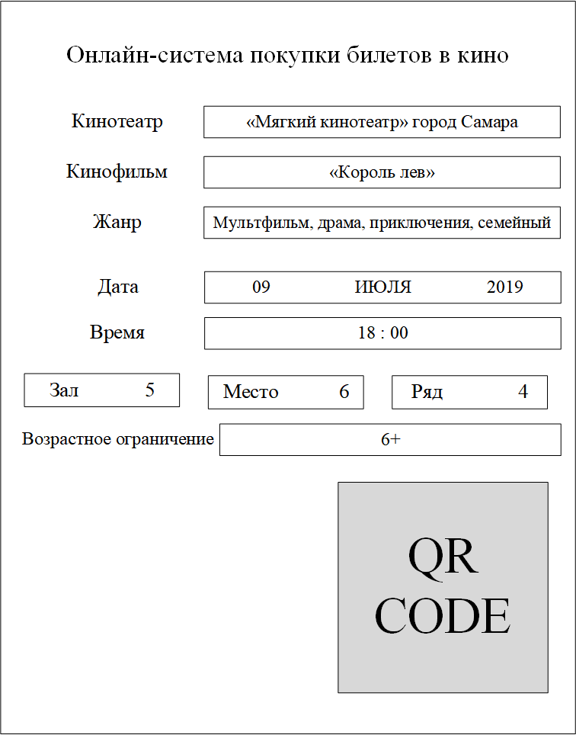  
Рисунок 6 – Пример купленного билета